# 🚀 Host a Static Website on Amazon S3
Abdulazeem Badmus

---

## 📑 Table of Contents
- [Project Overview](#project-overview)
- [Tools and Concepts](#tools-and-concepts)
- [How I Set Up an S3 Bucket](#how-i-set-up-an-s3-bucket)
- [Upload Website Files to S3](#upload-website-files-to-s3)
- [Static Website Hosting on S3](#static-website-hosting-on-s3)
- [Bucket Endpoint & 403 Error](#bucket-endpoint--403-error)
- [Success – Fixing the Error](#success--fixing-the-error)
- [Conclusion](#conclusion)

---

## 📘 Project Overview

In this project, I demonstrated how to host a **static website** using **Amazon S3**.
This hands-on project helped me understand the fundamentals of cloud deployment, S3 bucket configuration, static hosting, ACL permissions, and bucket policies.

This project took approximately **15 minutes** to complete.
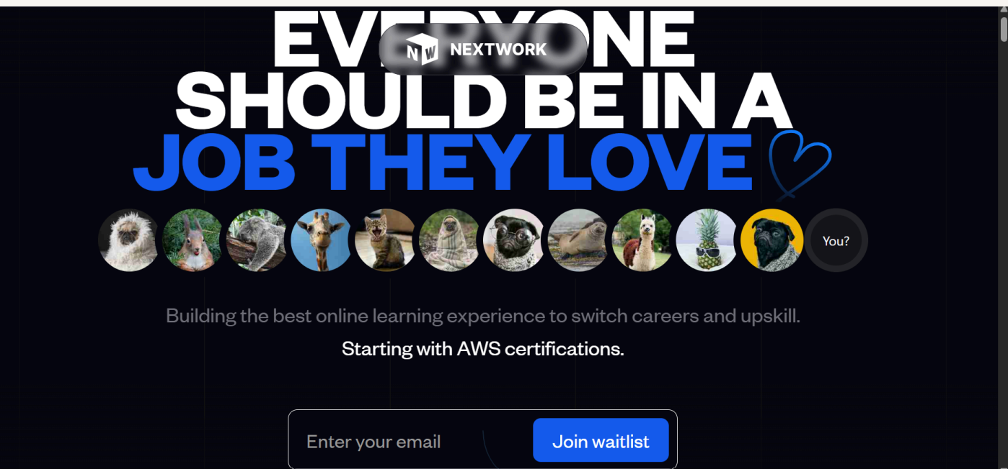

---

## 🛠 Tools and Concepts

### **AWS Services Used**
- Amazon S3
- IAM
- S3 Static Website Hosting

### **Key Concepts Learned**
- Object storage fundamentals
- Bucket naming rules
- ACLs (Access Control Lists)
- Bucket policies
- Static website hosting
- Cloud deployment workflow

---

## 🪣 How I Set Up an S3 Bucket

In this phase, I created the S3 bucket where the website files would be stored.
I also enabled static website hosting so S3 could serve the site publicly.

### 🔑 Key Points
- Bucket creation took **less than 2 minutes**
- Region selected: **af-south-1 (South Africa)** for lower latency . This is the region closer to me, it is best practice to choose the region closer to the user in other to improve the latency when retrieving or accessing the objects or file
- S3 bucket names must be **globally unique**
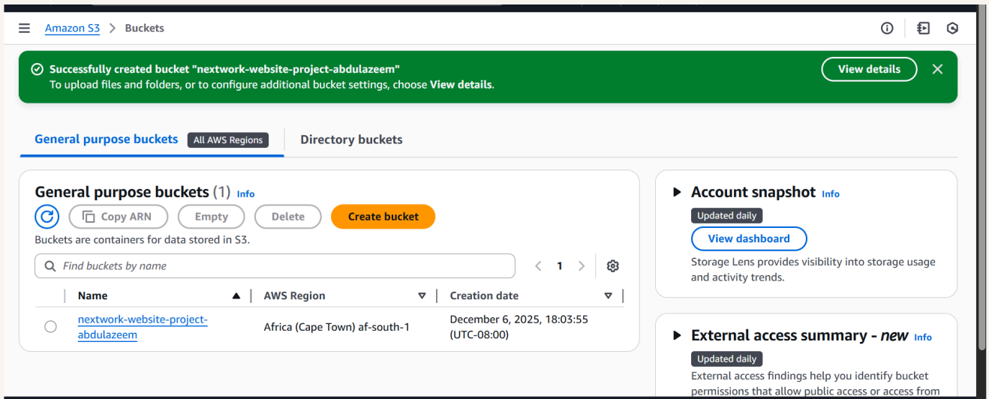
## 📤 Upload Website Files to S3

Next, I uploaded all website content — including the HTML file and the folder containing images referenced by the site.

### 💡 Why this matters
- The HTML file depends on the images
- Missing images = broken UI
- S3 must store the **same folder structure** used by the site
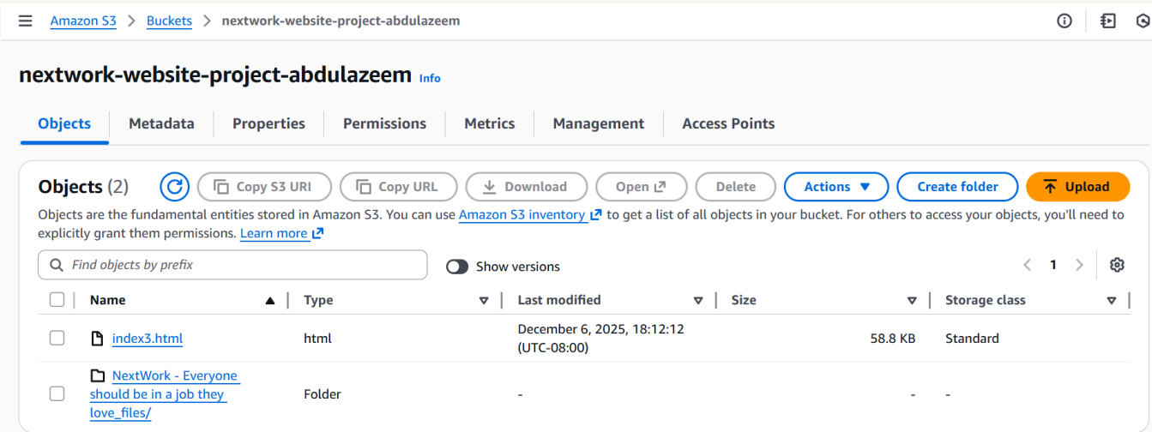---

## 🌐 Static Website Hosting on S3

I enabled **Static Website Hosting** from the bucket properties to generate a public URL for the website.

### 🔧 What I configured
- Enabled static website hosting
- Set the index document
- Generated the hosting endpoint
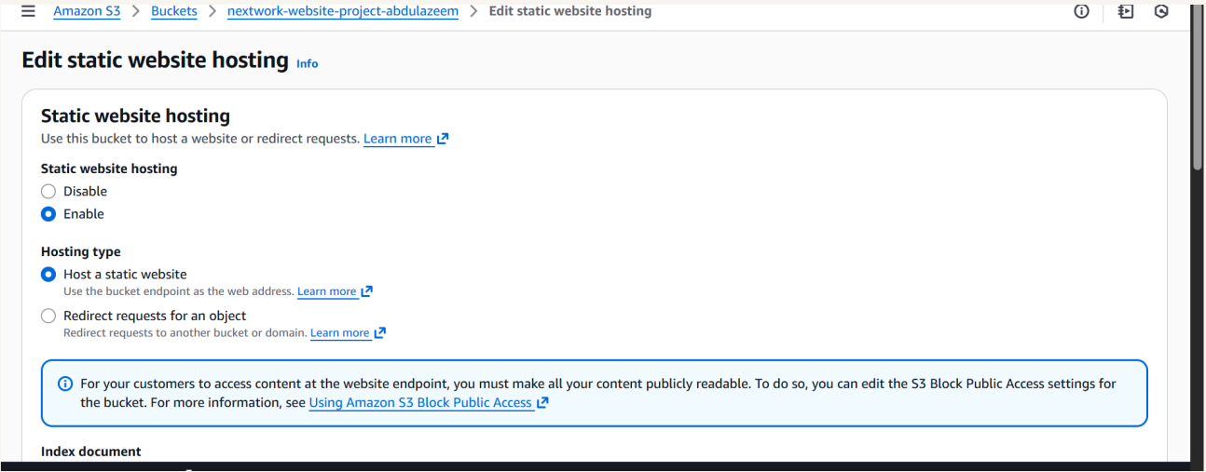

### 🔐 Understanding ACLs
ACLs determine who can view or modify objects.
To make a website public, objects must have **public read access**.

---

## 🚫 Bucket Endpoint & 403 Error

The first time I visited the S3 endpoint, I encountered a **403 Forbidden** error.

### ❗ Why this happened
Even though the bucket was public, the **objects themselves** didn’t have public permission.
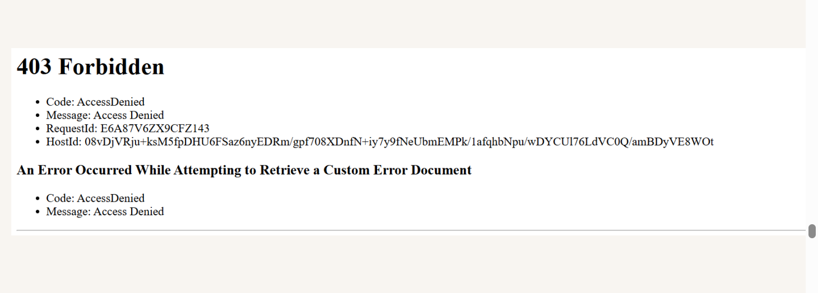---

## ✅ Success – Fixing the Error

To resolve the error, I applied **public read access** via ACLs to each uploaded object.

Once fixed, the website loaded successfully.

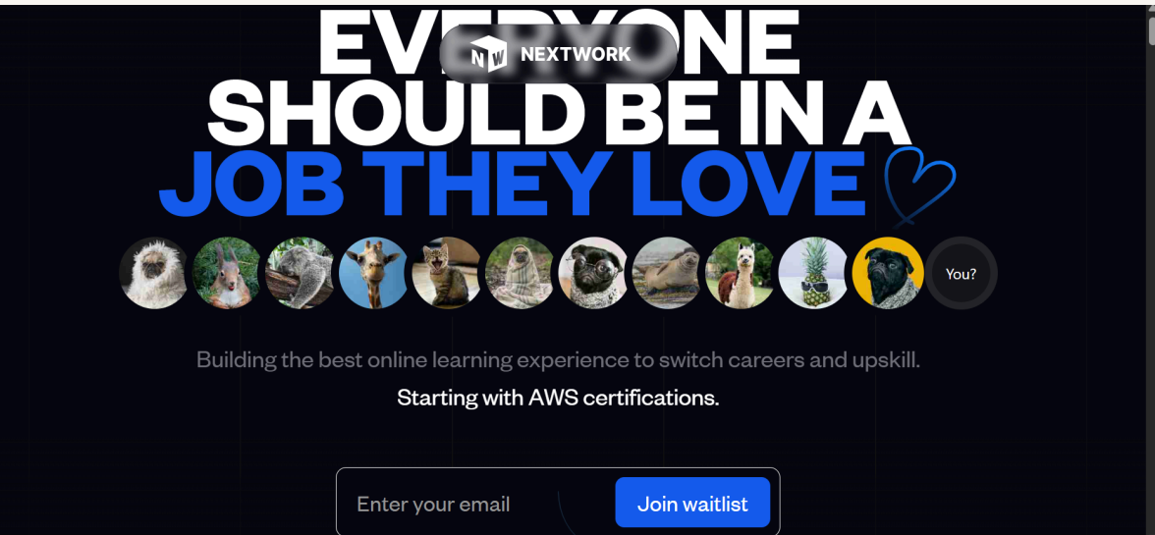---

## 🏁 Conclusion

Through this project, I learned how to:

- Create and configure an S3 bucket
- Upload and manage static assets
- Set up static website hosting
- Understand ACLs and public access
- Troubleshoot and fix 403 Forbidden errors
- Deploy a fully functional static website using AWS

This is a strong foundational cloud project demonstrating real-world AWS skills.

---

